Customer Retention & Churn Analysis Report
Synthetic subscription-business capstone deliverable

Executive Summary
The analysis covered 7,500 customers and found an overall churn rate of 50.7%. High-value customers churned above the baseline, while the top two churn reasons represented 59.0% of all churn events.
The best churn classifier was random forest with ROC-AUC 0.980. The results point to a clear retention priority: reduce early-life disengagement and service friction in the highest-risk segments.

Business Problem & Objective
The project aimed to identify churn patterns, quantify lifetime value risk, and translate those findings into specific retention actions for a subscription business.

Data Overview & Methodology
A synthetic raw dataset was created to mimic real client data quality issues, then cleaned into a single analysis-ready table. The workflow used pandas for preparation, seaborn/matplotlib for visualization, and scikit-learn for churn modeling.

Key Findings
- Overall churn rate: 50.7%
- Average CLV: 452.59
- Average tenure: 12.44 months
- Usage vs churn Spearman correlation: -0.45
- Support tickets vs churn Spearman correlation: 0.37
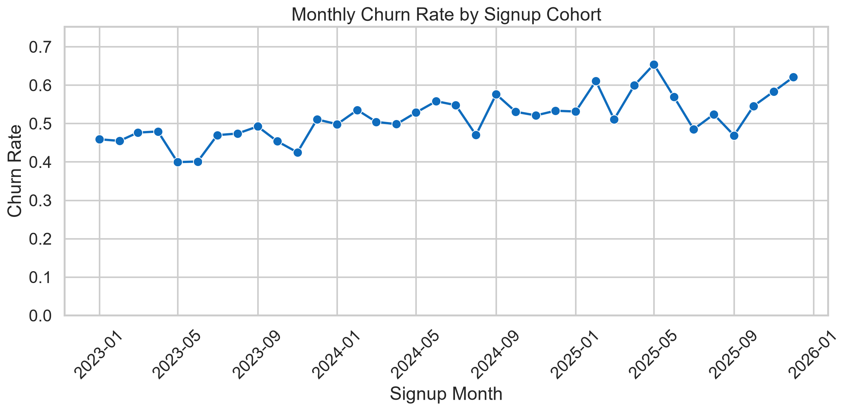
Figure 1. Monthly churn trend.
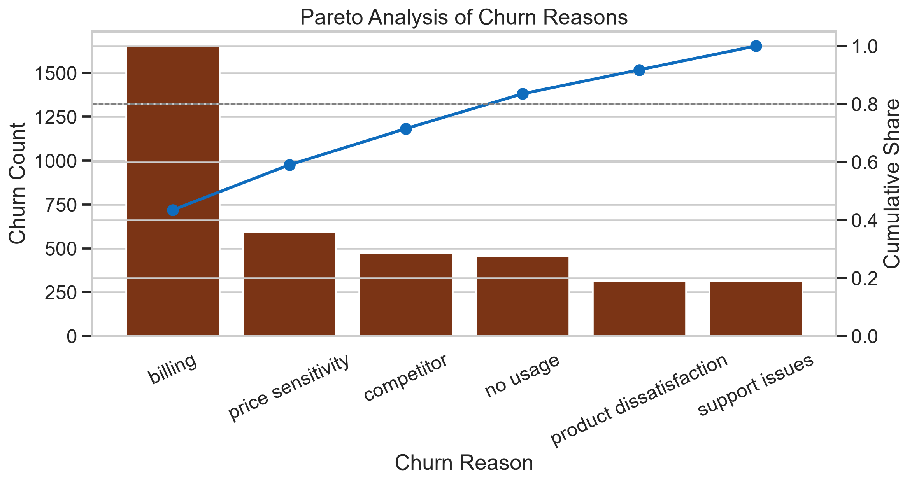
Figure 2. Pareto breakdown of churn reasons.
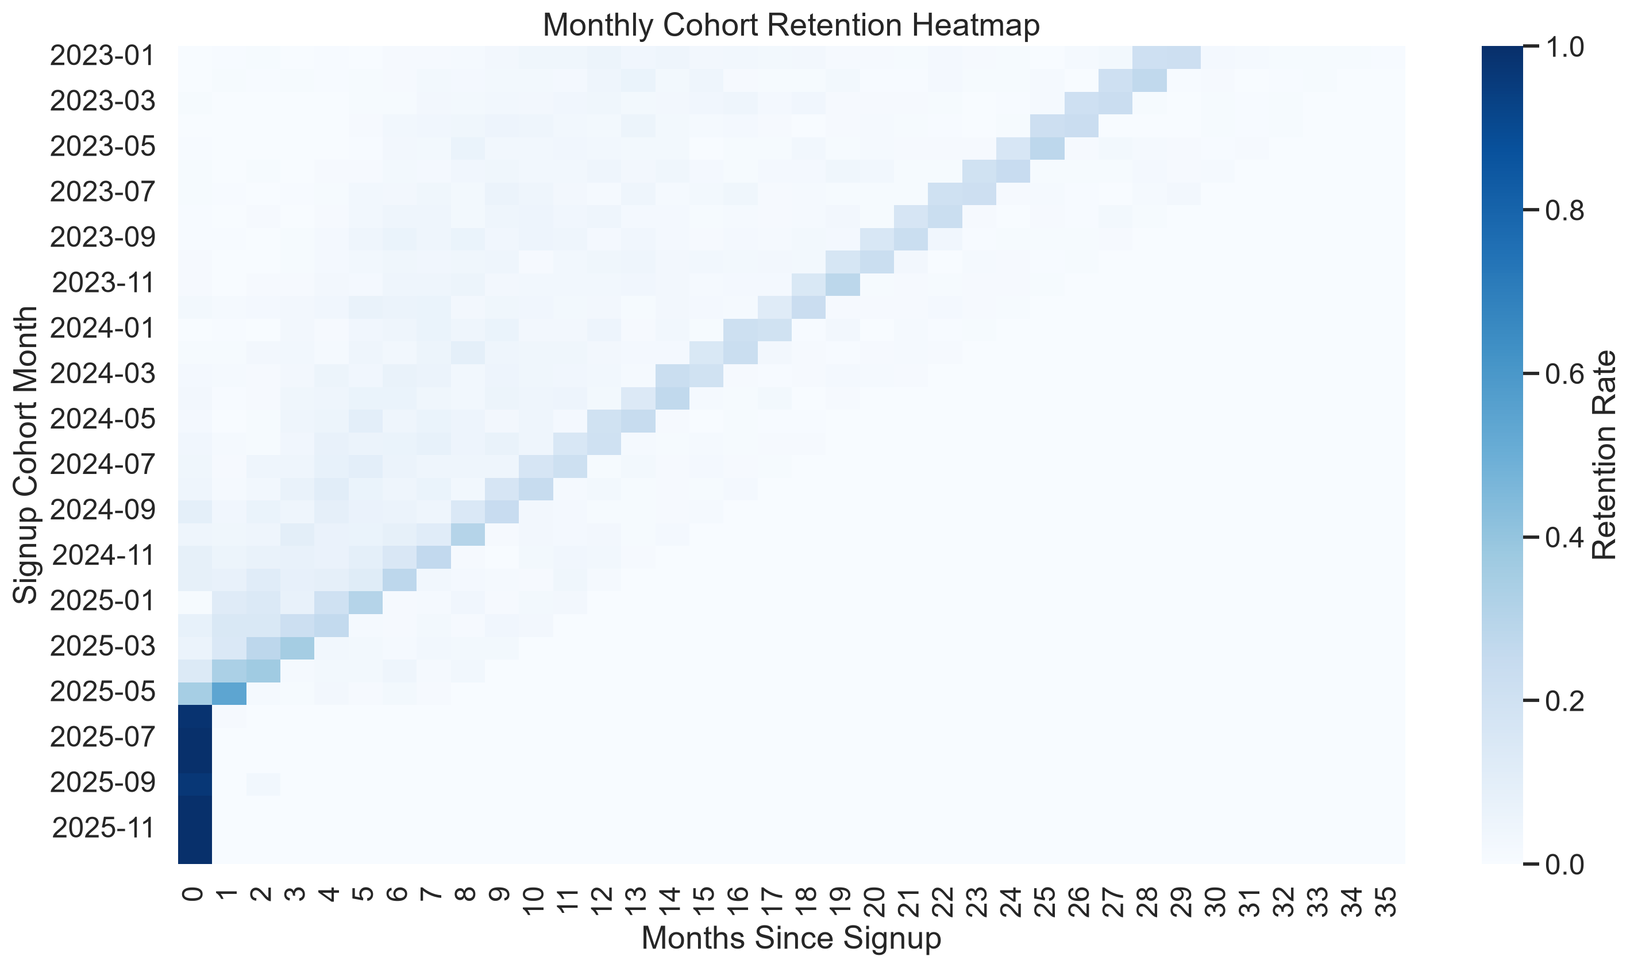
Figure 3. Monthly cohort retention heatmap.
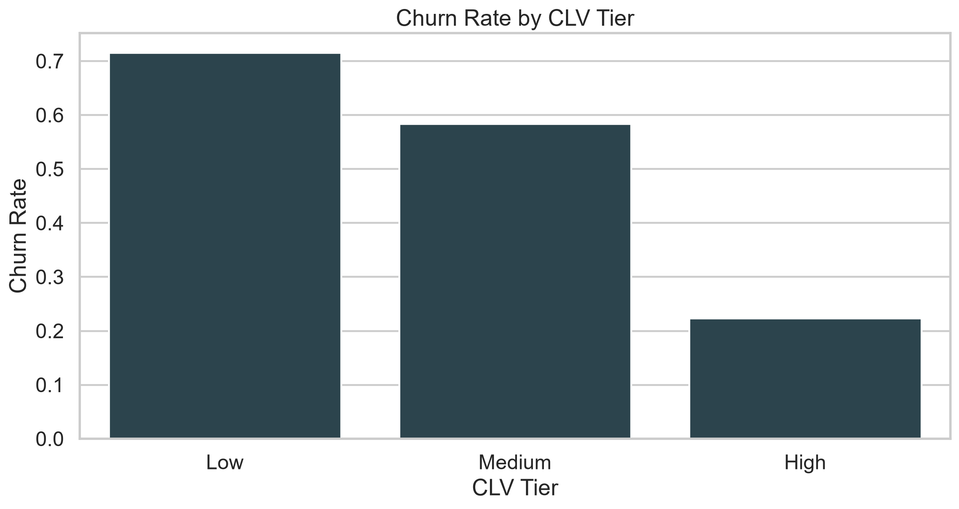
Figure 4. Churn rate by CLV tier.

Churn Prediction Model Summary & Top Drivers
The best model was random forest with ROC-AUC 0.980, precision 0.938, recall 0.931, and F1 0.935.

Actionable Recommendations

Recommendation 1: Attack the top churn reasons first
- The top two churn reasons account for 59.0% of all churn events.
- Create a billing-and-product retention playbook for customers citing billing, no usage, price sensitivity, and support issues.
- If targeted interventions reduce churn among those reasons by 20%, estimated overall churn could drop by about 6.0%.

Recommendation 2: Protect high-value customers
- High CLV customers churn at 22.3% versus 50.7% overall.
- Launch a high-value save desk for premium and high-CLV accounts with proactive renewal outreach and priority support.
- Closing half of the high-value churn gap could reduce total churn by roughly 0.0% and protect disproportionate revenue.

Recommendation 3: Intervene earlier on low-usage / high-support accounts
- Usage and support show meaningful churn separation (Spearman -0.45 and 0.37).
- Trigger lifecycle nudges, in-app education, and support escalation when engagement drops and ticket volume rises.
- A 10% reduction in churn among the highest-risk engagement segments could lower churn by about 4.1%.

Limitations & Future Work
The results are based on synthetic data and are intended to demonstrate end-to-end analytical rigor. In a real deployment, the model would be validated on time-based out-of-sample data and connected to intervention outcomes.

Appendix
Project artifacts:
- C:\Users\USER\Downloads\task 1\data\processed\subscription_customers_clean.csv
- C:\Users\USER\Downloads\task 1\data\processed\model_metrics.json
- C:\Users\USER\Downloads\task 1\data\processed\feature_importance.csv
- C:\Users\USER\Downloads\task 1\data\processed\cohort_retention_table.csv
- C:\Users\USER\Downloads\task 1\reports\model_card.md
- C:\Users\USER\Downloads\task 1\reports\customer_retention_churn_report.md

